Precision Farming ABHIVRIDDHI

**Description:**

The Precision Farming Robot involves multidisciplinary design and development using recent technological innovations in artificial neural networks, computer vision, and 3DExperience Design & Simulation software. It is an autonomous robot to perform functional and analytical operations such as Soil Health Monitoring and Precision in-row Weed Identification and removal, crop diseases identification, detection, and optimized pesticide use for controlling crop disease. The purpose is to develop a general-purpose, sustainable robotic system to enhance crop yield and reduce agriculture’s current dependency on herbicides thereby improving its impact on the environment.

**Innovation:**

1. Design & Development of functional robotic parts through Catia and Delmia software
2. Utilize the 3DExperience Simulia Platform for Design Simulation & Optimization, faster prototype product design through simulation of deep learning-based vision processing.
3. Development of Autonomous Navigation Algorithm, Vision based Deep Learning model for Soil health monitoring, Weed identification, and crop diseases identification, detection and optimized pesticide use for controlling crop disease.
4. Methodological attempt to reduce use of pesticides, herbicides through precision weed control thereby minimizing the harmful environmental impact of agrichemical leaching.

**Mechanical:**

Considering the application, this will be used in off road or muddy areas in agricultural field. Bot should sustain the forces acting on whole body and have high strength and stiffness. Following main components are chosen for better configuration of bot on working field.

1. Wheels

Wheels are used to transfer a vehicle's load from the [axle](https://en.wikipedia.org/wiki/Axle) through the wheel to the ground and to provide [traction](https://en.wikipedia.org/wiki/Traction_(engineering)) on the surface over which the wheel travels. Considering the ground situation such as irregular surface, mud, obstacles present in the working field. Wheels must have proper traction to run on irregular frictional surfaces. Therefore All Terrrain Wheels are selected for this application.

1. Wheel frame

Considering the bot size and weight, square frame made up of Mild Steel rods is used to provide better strength and can carry the load of chassis. Several operations like cutting, welding, finishing are used for manufacturing the wheel frame.

1. Chassis

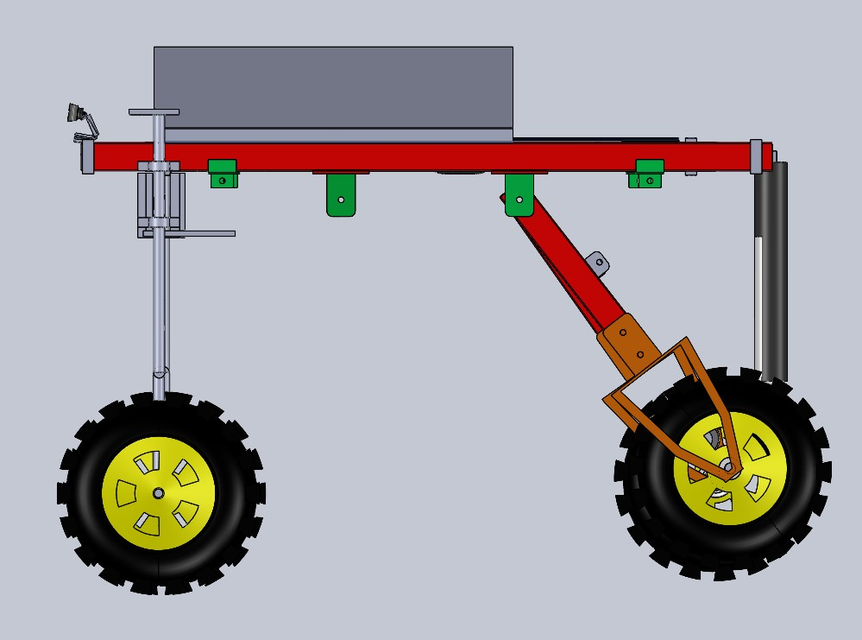

Chassis, also known as 'Frame', is the foundation structure of any car that supports it from underneath. The purpose of the chassis is to bear the weight of the car in its idle and dynamic states. To hold all the components of bot on single frame chassis is used. Simple and square chassis is selected to reduce weight. Chassis is build from Mild Steel 1 inch *1 inch square rods. Approximate of the chassis is around 5 to 7 kg.

1. Delta Arm

Delta arm is type of mechanism used to to acutate a single point as end effecter. The key concept of the delta robot is the use of parallelograms which restrict the movement of the end platform to pure translation, i.e. only movement in the X, Y or Z direction with no rotation. The mechanism has total of 3 degree of freedom which can locate coordinates according to the software.

1. Suspensions

Shock absorbers reduce the effect of traveling over rough ground, leading to improved [ride quality](https://en.wikipedia.org/wiki/Ride_quality) and [vehicle handling](https://en.wikipedia.org/wiki/Automobile_handling). While shock absorbers serve the purpose of limiting excessive suspension movement, their intended sole purpose is to damp spring oscillations. As the working of the bot is at off road site. Shock absorbers playes an important role to absorb the jerks and forces caused by irregular surfaces. Position of this shock absorber also helps in absorbing of sudden jerk supplied by the high powered DC geared motors.

**Electronics:**

AgriBot utilize power of two 250W Geared DC Motor for the locomotion and one power window motor which is used in car windows. The motor which we have used is from

HONDA CIVIC.

Motor used for locomotion:

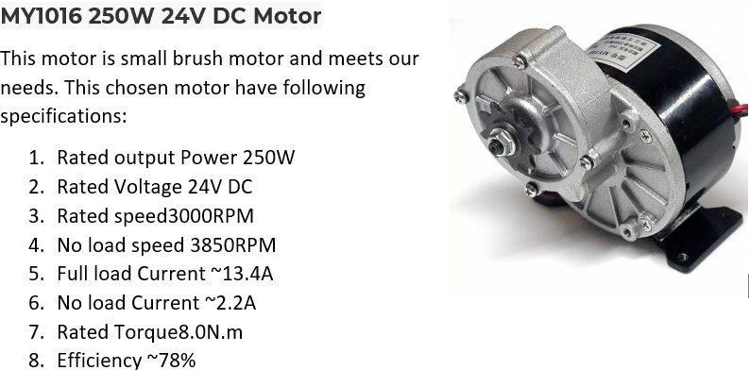

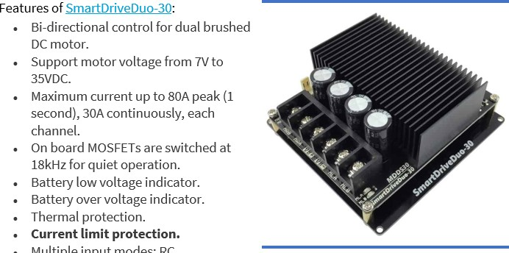

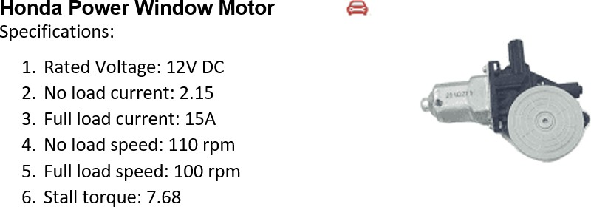

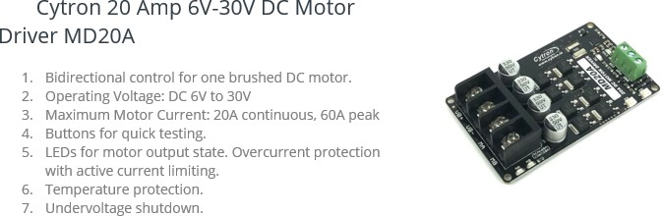

One of the mechanisms on our bot is delta arm robot which is made by using servos. We have selected 60kgcm servo for our mechanism. Specifications of the servo are as follows:

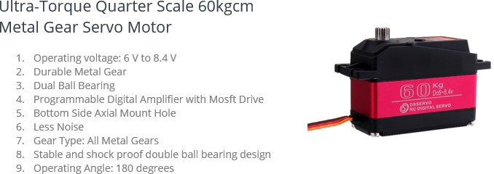

To spray the fertilizers and water, the spray mechanism is developed such it will have 90 degrees of motion. For providing this motion 35kgcm rated torque servo is selected. This motor can also provide actuations for any other intermediate angles.

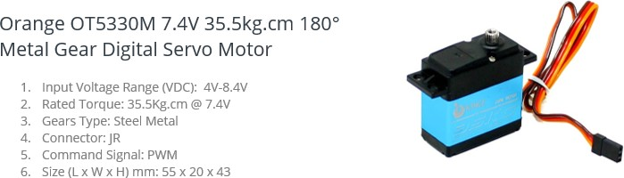

This was all about the motors for actuations but for providing the proper voltage and current to the spray mechanism and delta robot step down buck converters are used. The

specifications are as follows:

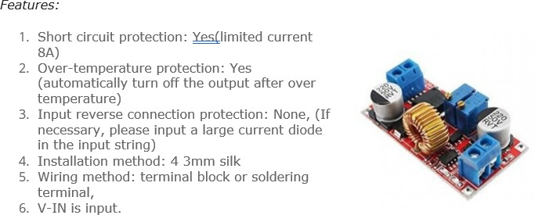

# Software:

1. **Weed Detection**

# YOLO

YOLO (you look only once) is a neural network capable of detecting the bounding boxes of objects in an image and the probability that they belong to a class in a single step. YOLO used convolutional networks and was selected for its good performance in object and pattern recognition, which has given it a recent good reputation in fields such as the recognition of means of transportation and animals, and the tracking of moving objects.

The first version of YOLO came out in 2016; its architecture consisted of 24 convolutional layers working as feature extractors and two dense or fully connected layers that performed predictions. YOLOv4 was used for its significant enhancements and feature extraction layers implemented by the Darknet-53 architecture.

As seen in Figure 1, once the model is trained to identify the crop, an algorithm uses bounding box coordinates from the model to remove crop samples from the image. To get the most out of YOLO in the effective detection of objects and speed, it was decided not to use edge detection and to consider the entire bounding box generated by the model as crops. However, this might affect weed calculation since the closest weed to the crop could be lost during estimation.

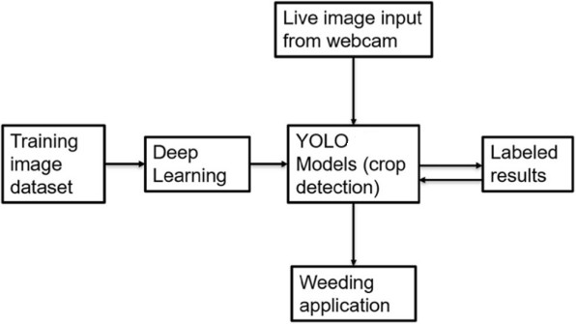

Phases of plant disease detection system.

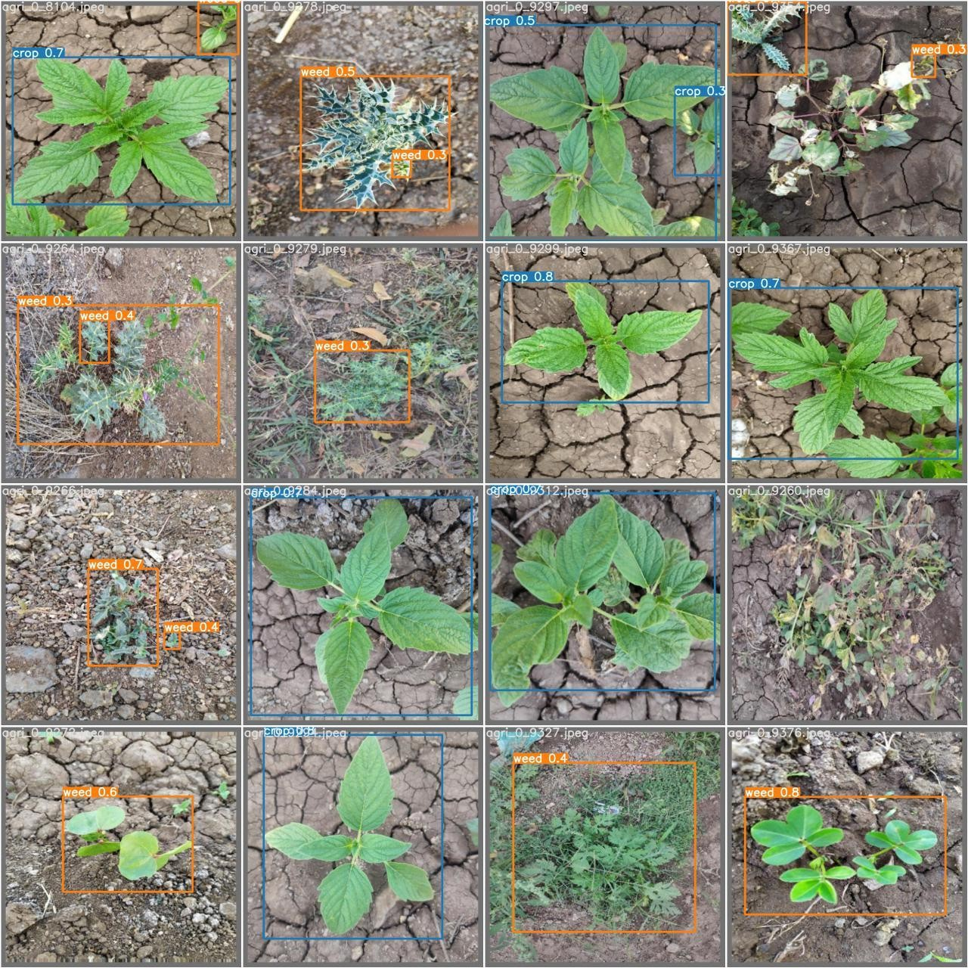

Bounding boxes generated which differentiates the crops and weeds

# Depth Estimation Using YOLO

Object depth estimation is the cornerstone of many visual analytics systems. In recent years considerable progress has been made in this area, while robust, efficient, and precise depth estimation in real-world video remains a challenge. The approach estimates the distance of surrounding weeds using a single camera.

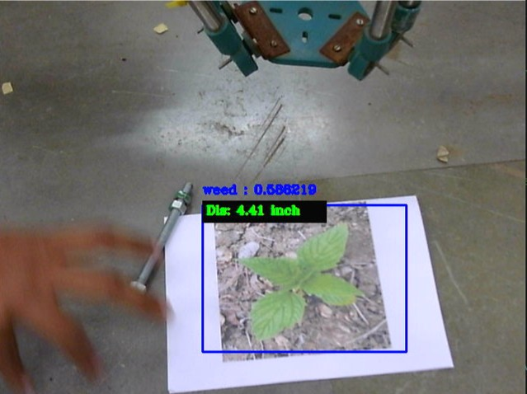

Weed prediction values and the estimated depth

YOLO generates a boundary box surrounding the object, and an inversion proportional correlation between the distance and the boundary box’s dimensions (height, width) is ascertained. YOLO also helps get the exact equation between the studied variables, the dependent variables such as the distance, the independent variable and the height and width of the boundary box.

# Darknet

Darknet is a convolutional neural network that is a backbone for the YOLO object detection approach. It is an open-source neural network framework written in C and

CUDA. It is fast, easy to install, and supports CPU and GPU computation. Darknet is implemented within the depth estimation system and works with the camera attached to the bottom of the robot (at a distance of 22 inches from the ground).

The pre-trained classes of the YOLO model didn’t contain any for plants and weeds. Using Darknet, the model was first prepared using the pre-trained tiny-YOLO model of approximately 1400 images of weeds and crops. The best weights with the lowest training loss were taken for distance estimation.

A reference image was taken based on the object’s distance from the camera, which was calculated manually. It was then assigned as a constant ‘KNOWN_WIDTH’. The width of the weed image in real-time was approximated and set using a ‘WEED_WIDTH’ constant. These values were necessary for determining the camera’s focal length used for which a function was implemented. With the help of these reference images and the trained weights, the model could differentiate between crop plants and weeds and simultaneously display their distances from the camera in inches.

For detection purposes, the OpenCV method of cv2.dnn_DetectionModel() was implemented. It is a class representing high-level API for object detection networks. It enables setting the parameters for pre-processing the input image and creates a net from the file with trained weights and config (which was set up and configured beforehand based on the changes necessary in tiny YOLO’s configuration file). This class sets the pre-processing input, runs forward pass and returns the result detections. It also supports YOLO topology, apart from SSD and Faster R-CNN.

# GUI

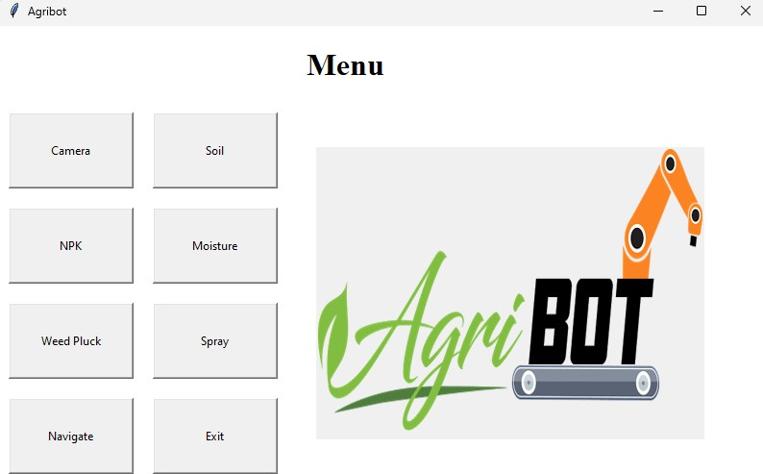

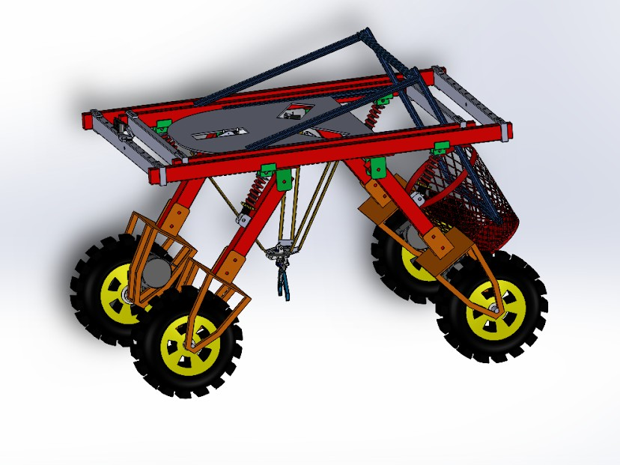

Simulation Diagram of Precision Farming Robot